Chapter 9, Problem 36.

Using Fig. 9.43, design a problem to help other students better understand impedance.

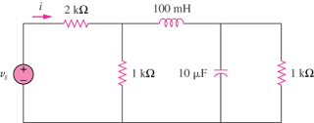
R₁
v_{s}
C
R₃
R₂
L
i

Figure 9.43
For Prob. 9.36.

